Dcache ERROR DOCUMENTATION
Introduction:
The purpose of this document is to identify, categorize, and analyze errors observed in the dcache (data cache) implementation of the uetrv_pcore. It highlights the potential causes, impacts, and recommended fixes for these errors to ensure reliable system behavior.
Overview of dcache in uetrv_pcore:
The dcache module in uetrv_pcore is responsible for managing data memory accesses by reducing latency and improving performance. It handles features such as:
- Cache hits and misses.
- Direct Mapping
- Eviction and replacement policies.
- Handling memory requests and responses.
Errors in the dcache can impact the overall performance, correctness, and efficiency of the processor core.
Error no. 1:
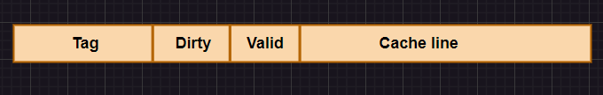
First of all, the thing that we noticed was that the cache memory consisted of cache line which further consisted of 4 words (one word being 32 bits), valid bit, dirty bit and tag bits. This cache memory was initialized as don’t cares which meant that the valid bit was always going to be don’t care in every case.
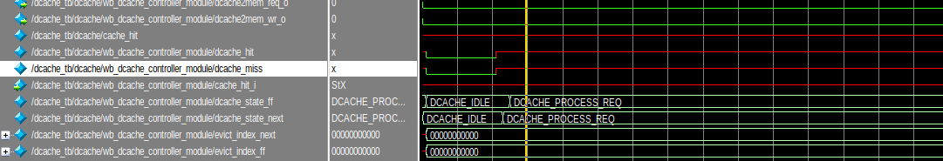

cache_hit_i is "don't care" because the valid bit for the cache is not initialized properly. This means that the cache controller cannot reliably determine whether there’s a cache hit or cache miss.
Impact on dcache_state_ff and dcache_state_next:
Since cache_hit_i is "don't care (due to which dcache_miss is also don’t care)," the FSM logic is likely unable to make a valid decision about transitioning states. As a result, the FSM remains stuck in the DCACHE_PROCESS_REQ state, unable to proceed further until the valid bit is properly initialized or a definite signal is provided for cache_hit_i. If the valid bit would have been 0, it would have transitioned to DCACHE_IDLE state from DCACHE_PROCESS_REQ state. If the valid bit would have been 1, it would have transitioned to DCACHE_ALLOCATE state.
Anomaly:
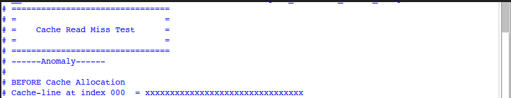
The anomaly observed during the Cache Read Miss Test occurs because the valid bit of cache line at index 000 is uninitialized, leaving its contents and valid bit in an undefined state (x). This causes the cache controller to misinterpret the state of the cache, resulting in incorrect behavior such as cache_hit_i being treated as "don't care."
Solution:
The signal cache_hit_i is the input to the controller and cache_hit_o is the output of datapath.
The cache_hit_o signal is set to true if the tag from the requested address (addr_tag_ff) matches the tag stored in the cache (cache_tag_read.tag) and the other signal being the valid bit of cache (cache_tag_read.valid). The valid bit is don’t care so we need to modify the code for valid bit. The modified code is shown below:
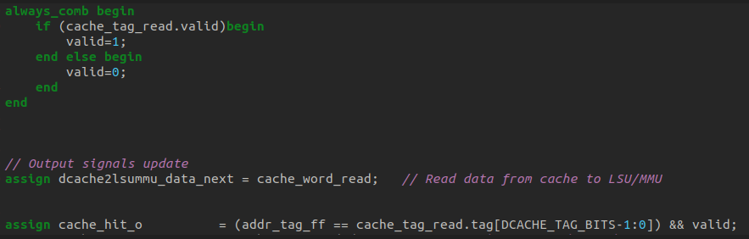

- If cache_tag_read.valid is true (logic high), the valid signal is set to 1, signaling that the cache line is valid and can be used.
- If cache_tag_read.valid is false (logic low), the valid signal is set to 0, indicating cache miss.
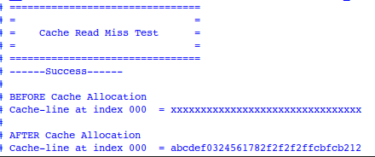
The test result demonstrates the successful handling of a Cache Read Miss. Initially, the cache-line at index 000 is shown by undefined data (xxxxxxxxxxxxxxxxxxxxxxxxxxxxxxxx). After the read miss is detected, the system fetches the required data from memory and updates the cache-line with valid data (abcdef0324561782f2f2f2ffcbfcb212). The "Success" message confirms that the cache correctly allocates data after a miss, validating the cache controller's functionality.
Error no. 2:
addr_index likely represents the address index used for selecting or operating on a specific cache line in a data cache operation. The first condition checks if dcache_flush is asserted, in which case addr_index takes the value of evict_index, likely pointing to the index of a cache line to be flushed. If dcache_flush is not asserted but cache_wr_i is true, it assigns the value of addr_index_ff, which may be a previously stored or forwarded index related to a cache write operation. If neither dcache_flush nor cache_wr_i are true, addr_index is set to the extracted bits from lsummu2dcache_addr_i, specifically a range determined by DCACHE_TAG_LSB and DCACHE_OFFSET_BITS.
The above simulation shows that addr is don’t cares.

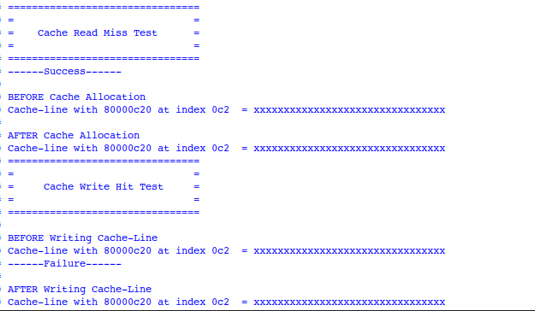
The testing focuses on read misses and write hits. During the Cache Read Miss Test, the cache line at index 0c2 is empty (all Xs) before allocation and is still all Xs after allocation, indicating some issue in handling of the miss. In the Cache Write Hit Test, the cache line at index 0c2 remains unchanged (all Xs) both before and after writing, indicating a failure in correctly updating the cache during a write hit. This suggests a possible issue with the write hit handling mechanism.
Solution:
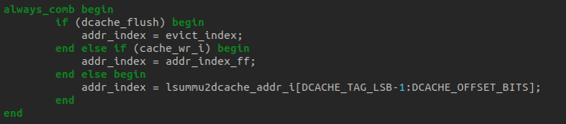
We just used always_comb block to create the logic for addr_index.
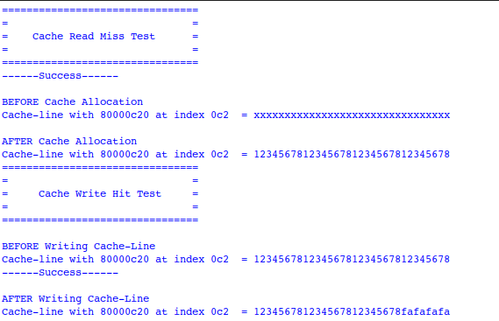
The testing focuses on read misses and write hits. In the Cache Read Miss Test, the cache line at index 0c2 is initially invalid (Xs) before allocation but is successfully loaded with valid data (12345678...) after allocation, indicating proper handling of a cache miss. In the Cache Write Hit Test, the cache line at index 0c2 starts with valid data and is correctly updated with new data (fafafafa) while retaining the rest of the content, showing successful write hit handling.
Error no. 3:
When flushing is done, and the testing of cache read miss is done, it gives us failure. This is an error because once the flushing is done, it should give us success.
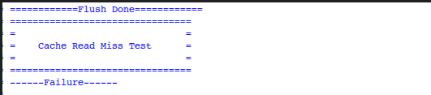
This failure is because of the valid bit which is the 9th bit from MSB side. This valid bit is 1 which leads us to failure because nalid bits should be clear after flushing but in fact, it doesn’t happen. We need to fix this error.
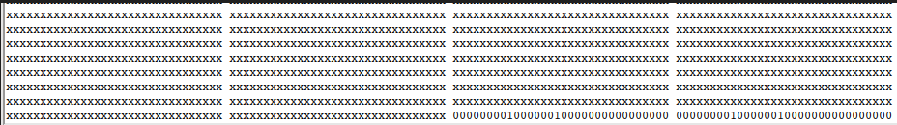

Solution:
We resolved this error by fixing the valid bit which is the 9th bit from MSB side to 0. This is done, so that after flushing, the data cannot be used.
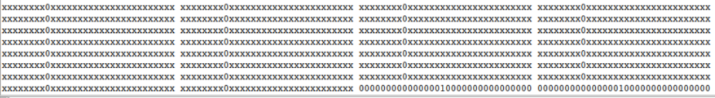
A separate condition within a generate loop for a cache checks if dcache_flush is asserted, then a valid bit (e.g., bit 23) of the cache memory entry is cleared (set to zero).
